**MySQL Exercise 6**

1.

DELIMITER //

CREATE PROCEDURE Comp_intr(IN principal FLOAT, IN rate FLOAT, IN years INT, OUT interest FLOAT)

BEGIN

DECLARE amount FLOAT;

-- Calculate the total amount after compounding

SET amount = principal * POWER((1 + rate), years);

-- Calculate the interest earned

SET interest = amount - principal;

END //

DELIMITER ;

-- Declare a variable to hold the interest

SET @interest = 0;

-- Call the stored procedure

CALL Comp_intr(1000, 0.05, 5, @interest);

-- Display the result

SELECT @interest AS TotalInterest;

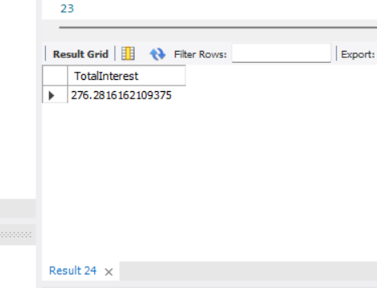

2.

DELIMITER //

CREATE FUNCTION Age_calc(dob DATE)

RETURNS INT

DETERMINISTIC

BEGIN

DECLARE age INT;

-- Calculate age by finding the difference in years

SET age = YEAR(CURDATE()) - YEAR(dob);

-- Adjust for whether the birthday has occurred this year

IF DATE_FORMAT(dob, '%m%d') > DATE_FORMAT(CURDATE(), '%m%d') THEN

SET age = age - 1;

END IF;

RETURN age;

END //

DELIMITER ;

SELECT Age_calc('1990-05-15') AS Age;

